

MIZAN TEPI UNIVERSITY

SCHOOL OF COMPUTING AND INFORMATICS
DEPARTMENT OF INFORMATION TECHNOLOGY
PROJECT OF FUNDAMENTALS OF DATABASES SYSTEM

TITLE : DESIGN OF ONLINE EXAMINATION INFORMATION DATABASE SYSTEM

SECTION : A GROUP : 2

NO. | NAME OF STUDENT | STUDENT ID
1 | ADDISU GASHU | MTUUR/8189/17
2 | BEREKET MOLLA | MTUUR/ 8282/17
3 | DESALEGN ANDUALEM | MTUUR/ 8882/17
4 | EPHREM NEGA | MTUUR/ 7779/17
5 | HIWET ASHEBER | MTUUR/ 7877 /17

SUBMITE TO : MR/ BIRHANU
SUBMITION DATE : 04/05/2018 E.C

MIZAN TEPI UNIVERSITY ............................................................................................................. I
CHAPTER ONE........................................................................................................................1
1.1 Introduction......................................................................................................................... 1
1.2 Objective...................................................................................................................... 1
1.3 Problem Statement......................................................................................................2
1.4 Scope of the Project....................................................................................................3
1.5 Literature Review / Background.................................................................................. 4
1.6 Overview of Database Systems................................................................................... 4
1.7 Online Examination Systems....................................................................................... 4
1.8 Role of Databases in Online Examination....................................................................4
1.9 File_Based vs Database Approach.............................................................................. 5
1.10 DBMS Concepts Relevant to This Project.................................................................. 6
1.11 Data Models (Hierarchical, Network, Relational)......................................................6
1.12 Data Independence....................................................................................................7
1.12 Three-Schema Architecture.......................................................................................7
1.13 Database Users and Roles..........................................................................................8
1.14 Database Languages.................................................................................................. 8
CHAPTER TWO........................................................................................................................... 8
SYSTEM ANALYSIS ...................................................................................................................... 8
2.1 Requirements Analysis.................................................................................................8
3.2 User Analysis................................................................................................................9
2.3 Input/Output Design..................................................................................................10
CHAPTER THREE .......................................................................................................................11
Conceptual Design................................................................................................................... 11
3.1 Entity-Relationship (ER) Diagram.......................................................................................12
Entities:............................................................................................................................ 12
Relationships:...................................................................................................................12
3.1.1 Entities and Relationships.......................................................................................12
3 .2 Attributes: Key and Non-Key Attributes................................................................... 14
3.3 Cardinality: Relationship Types..................................................................................14
CHAPTER FOUR........................................................................................................................ 15
Logical Design.......................................................................................................................... 15
4.1 Convert ER Diagram to Relational Schema ........................................................................15
4.2 Normalization.................................................................................................................... 16
4.2.1 Application of Normal Forms..................................................................................17
EXAMPL.3.................................................................................................................................25
CHAPTER FIVE .......................................................................................................................... 28
Physical Design.......................................................................................................................29
5.1 Database Creation..................................................................................................... 29
5.2 Data Insertion............................................................................................................ 31
CHAPTER SIX............................................................................................................................ 32
Results and Discussion.............................................................................................................32
6.1 Outputs (Reports, Forms, Query Results)..................................................................32
6.2 Discussion: How the System Meets Objectives.........................................................35
6.3 Limitations................................................................................................................. 35
Conclusion and Future Scope.......................................................................................... 37
References....................................................................................................................... 38

CHAPTER ONE

1.1 Introduction

Designing an online examination system involves creating a relational database schema to
manage users, exams, questions, and results securely and efficiently. The core starts with an
Entity-Relationship Diagram (ERD) that models key entities like Admin, Student (or
Examinee), Subject, Examination, Question, and Result, along with their attributes and
relationships such as one-to-many (e.g., one exam to many questions) . Normalization is
applied to eliminate redundancy, with primary keys in every table and indexes for fast
searches
For a computer science student, understanding database systems is essential because these
systems form the foundation for managing large volumes of data efficiently in real-world
applications.
In contrast Database systems store all data centrally, avoid duplication, and let many people
access data simultaneously. They provide better security, easier data management, and faster
searching, making them suitable for complex and large-scale applications .

1.2 Objective

The objective of the Online Examination Database System is to develop a well-structured,
centralized, and secure database that efficiently stores, organizes, and manages all
information required for conducting examinations digitally. This includes data related to
students, instructors, courses, exam schedules, questions, exam papers, submissions, and
results.
The system aims to eliminate traditional manual examination methods by automating the
entire exam process—from creating exam questions and assigning exams to students, to
recording responses and generating accurate results. By providing fast data retrieval,
improved accuracy, and enhanced security, the system supports administrators, teachers, and
students in conducting examinations smoothly and transparently.
1In addition, the database is designed to ensure data integrity, reduce administrative workload,
minimize human error, and allow easy scalability as the number of users and exams increases.
The system ultimately enhances the overall examination experience through efficient data
management, flexible access, and reliable performance.

1.3 Problem Statement

Most educational institutions continue to rely on semi-manual examination processes,
which involve paper-based question preparation, manual scoring, and fragmented record-
keeping. While these methods have been used for decades, they present significant challenges
in today’s digital era:
Time-consuming exam preparation: Preparing question papers, printing, and distributing
them requires extensive effort and delays.
Human errors in scoring or question management: Manual evaluation increases the risk of
mistakes, miscalculations, and inconsistencies.
Difficulty in handling large numbers of students: Scaling exams for thousands of students
becomes inefficient and prone to logistical issues.
Data redundancy and inconsistency: Storing exam records in multiple files or formats leads
to duplication and mismatched information.
Inefficient storage and retrieval of exam records: Locating past results or student
performance data is slow and unreliable.
Poor security of exam questions and student results: Paper-based systems are vulnerable to
leaks, unauthorized access, and tampering.
To overcome these limitations, an online examination database system provides a modern
solution by integrating automation, security, and efficiency:
2Automated question storage: Questions are stored digitally, categorized, and reused without
duplication.
Timely exam preparation: Exams can be generated quickly using stored question banks.
Secure result management: Results are encrypted, access-controlled, and protected against
manipulation.
Fast retrieval of student data: Student records and performance reports can be accessed
instantly with search queries.

1.4 Scope of the Project

The proposed online examination database system is designed to streamline and automate
core examination-related processes within educational institutions. Its scope encompasses the
following major functions:
✓ Maintaining student records: The system will store and manage essential student
information, including personal details, enrollment data, and academic history.
✓ Storing exams and their schedules: Exam timetables and related metadata will be
organized digitally, ensuring timely scheduling and easy updates.
✓ Managing exam questions: A centralized question bank will support multiple formats
such as multiple-choice, true/false, and short-answer questions, categorized for reuse and
efficient retrieval.
Conceptual schema: This represents the logical structure of the entire database, typically
modeled using Entity-Relationship (ER) diagrams. It defines entities, attributes, and
relationships without concern for physical storage details.
External schema: This layer provides customized views tailored to different users. For
example, students may only see their exam results, while instructors access question banks
and schedules.
1.13 Database Users and Roles

Different roles interact with the system, each with specific responsibilities:
✓ Admin: Manages users, exams, and overall system configuration.
✓ Instructor: Uploads questions, schedules exams, and monitors student progress.
✓ Students: Participate in exams and access their results.
✓ System: Automatically evaluates exams and generates results.
1.14 Database Languages

✓ DBMS uses specialized languages to define and manipulate data:
✓ DDL (Data Definition Language): Commands like CREATE TABLE define structures.
✓ DML (Data Manipulation Language): Commands such as INSERT, UPDATE, and
DELETE manage records.
✓ DCL (Data Control Language): Commands like GRANT and REVOKE control access
and permissions.

CHAPTER TWO

SYSTEM ANALYSIS

2.1 Requirements Analysis
A requirements analysis defines the essential features and constraints of the proposed online
examination database system. It ensures that the system meets institutional needs while
maintaining efficiency, security, and scalability. Requirements are classified into functional
and non-functional categories.
2.1.1 Functional Requirements
Functional requirements describe the core operations the system must perform to support
examination management. The system should allow:
✓ Add/update/delete student records: Maintain accurate and up-to-date student information.
✓ Add/update/delete exam information: Manage exam schedules, subjects, and metadata.
✓ Add exam questions: Support multiple formats such as MCQs, true/false, and short
answers.
✓ Automatically calculate exam results: Provide instant scoring to reduce human error.
✓ Allow students to take online exams: Enable secure participation through digital
interfaces.
✓ Allow teachers to manage exams: Facilitate question uploads, exam scheduling, and
monitoring.
✓ Allow admin to manage users: Control system access, roles, and overall configuration.
2.1.2 Non-Functional Requirements
Non-functional requirements define the quality attributes and constraints of the system. These
ensure that the system is not only functional but also reliable and user-friendly:
✓ Security: Password protection, authorization, and encryption safeguard sensitive exam
data.
✓ Performance: Fast query execution ensures smooth operation even under heavy load.
✓ Reliability: Mechanisms to prevent data loss guarantee consistent availability.
✓ Usability: A simple interface makes the system accessible to students, instructors, and
administrators.
✓ Scalability: The system can expand to accommodate more students, exams, and data
without performance degradation.
3.2 User Analysis
User analysis involves identifying the different categories of individuals and system
components that interact with the online examination database. Each user has distinct
responsibilities, access levels, and requirements. Proper identification of users ensures that
the system is designed with appropriate roles, permissions, and functionalities.
Types of Users
Administrator:
✓ Manages overall system operations.
✓ Creates and maintains user accounts.
✓ Oversees exam schedules and ensures data security.
✓ Assigns roles and permissions to instructors and students.
Instructor:
✓ Uploads and manages exam questions.
✓ Prepares and schedules examinations.
✓ Monitors student performance and generates reports.
✓ Ensures exam content integrity.
Student:
✓ Registers and maintains personal records.
✓ Takes online examinations securely.
✓ Views results and feedback.
✓ Interacts with the system through a simplified interface.
System (Automated Component):
✓ Evaluates exam submissions automatically.
✓ Calculates and stores results.
✓ Provides instant feedback to students.
✓ Ensures reliability and consistency in scoring.
2.3 Input/Output Design
Input/output design defines how data enters the system and how processed information is
presented to users. In the context of an online examination database, inputs are primarily
captured through structured forms, while outputs are generated as reports, queries, and
automated results. This design ensures smooth interaction between users and the database,
supporting accuracy, usability, and efficiency.
Expected Inputs
The system will provide forms to capture and manage essential data:
Student registration forms: Collect personal details, enrollment information, and login
credentials.
Exam creation forms: Allow instructors to define exam metadata such as subject, date,
duration, and instructions.
Question entry forms: Enable instructors to upload exam questions in multiple formats
(MCQ, true/false, short answers).
User management forms: Allow admins to add, update, or delete user accounts and assign
roles.
Exam attempt forms: Provide students with secure interfaces to submit answers during
online exams.
Expected Outputs
The system will generate outputs that provide meaningful insights and feedback:
Student performance reports: Summarize exam results, scores, and progress over time.
Exam result queries: Allow retrieval of individual or group results instantly.
Question bank reports: Provide listings of available questions categorized by subject or
difficulty.
System activity logs: Track user actions for security and auditing purposes.
Administrative reports: Summarize exam schedules, student participation, and overall
system usage.

CHAPTER THREE

Conceptual Design

Conceptual design defines the high-level structure of the database, focusing on entities,
attributes, and relationships. It provides a blueprint for how data will be organized and
connected in the online examination system.
3.1 Entity-Relationship (ER) Diagram

The ER diagram models the main entities and their relationships. Key entities include:
Entities:
Student
Exam
Question
Result
Instructor
Admin
Relationships:
A student takes an exam.
An exam contains multiple questions.
A student receives a result for each exam attempt.
An instructor creates exams and uploads questions.
An admin manages users and system operations.

3.1.1 Entities and Relationships

The conceptual design of the online examination system is built around six core entities. Each
entity represents a major component of the system, and the relationships define how these
components interact to support examination workflows.

3.2.1 Entities and Their Descriptions
Entity
Description
Student Represents individuals who take exams and receive results.
Exam Represents scheduled assessments created by instructors.
Question Represents individual questions linked to exams and uploaded by
instructors.
Result Represents the outcome of a student's exam attempt, generated by the
system.
Instructor Represents academic staff who create exams and upload questions.
Admin Represents system administrators who manage users and oversee
operations.

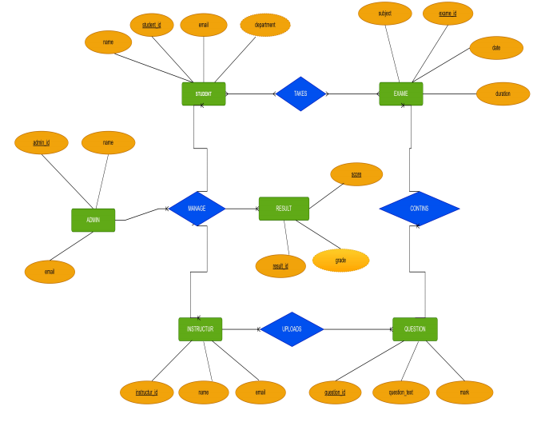

3 .2 Attributes: Key and Non-Key Attributes

Each entity in the online examination system contains key attributes (used to uniquely
identify records) and non-key attributes (used to describe or support the entity).
Entity
Key Attribute
Non-Key Attributes
Student
student_id
name, email, department, password
Exam
exam_id
subject, date, duration
Question
question_id
question_text, question_type, marks
Result
result_id
score, grade, feedback
Instructor instructor_id
name, email
Admin
admin_id
name, email
3.3 Cardinality: Relationship Types
Cardinality defines how many instances of one entity relate to instances of another. The
online examination system includes both one-to-many and many-to-many relationships:
Relationship Entities Involved
Cardinality
Description
Takes
Student–Exam
Many-to-Many
A student can take multiple
exams; each exam can be taken by many students.
Contains
Exam–Question
One-to-Many
Each exam contains multiple questions.
Receives
Student–Result
One-to-Many
Each student receives multiple results.
Creates
Instructor–Exam
One-to-Many
Each instructor can create multiple exams.
Uploads
Instructor–Question
One-to-Many
Each instructor can upload multiple questions.
Manages
Admin – Users (Student & Instructor)
One-to-Many
Admin manages multiple student and instructor accounts.

CHAPTER FOUR

Logical Design
Logical design transforms the conceptual ER model into a set of normalized relational tables.
This step ensures that the database structure is efficient, consistent, and free from redundancy.

4.1 Convert ER Diagram to Relational Schema

Based on the ER diagram, the following relational schema is derived:
STUDENT
✓ student_id (PK)
✓ name
✓ email
✓ department
✓ password
INSTRUCTOR
✓ instructor_id (PK)
✓ name
✓ Email
ADMIN
✓ admin_id (PK)
✓ name
✓ email
EXAM
✓ exam_id (PK)
✓ subject
✓ date
✓ duration
✓ instructor_id (FK → INSTRUCTOR) QUESTION
✓ question_id (PK)
✓ question_text
✓ question_type
✓ marks
✓ exam_id (FK → EXAM)
✓ instructor_id (FK → INSTRUCTOR)
EXAM_ATTEMPT
✓ attempt_id (PK)
✓ student_id (FK → STUDENT)
✓ exam_id (FK → EXAM)
✓ timestamp
RESULT ✓ result_id (PK)
✓ score
✓ grade
✓ feedback
✓ student_id (FK → STUDENT)
✓ exam_id (FK → EXAM)
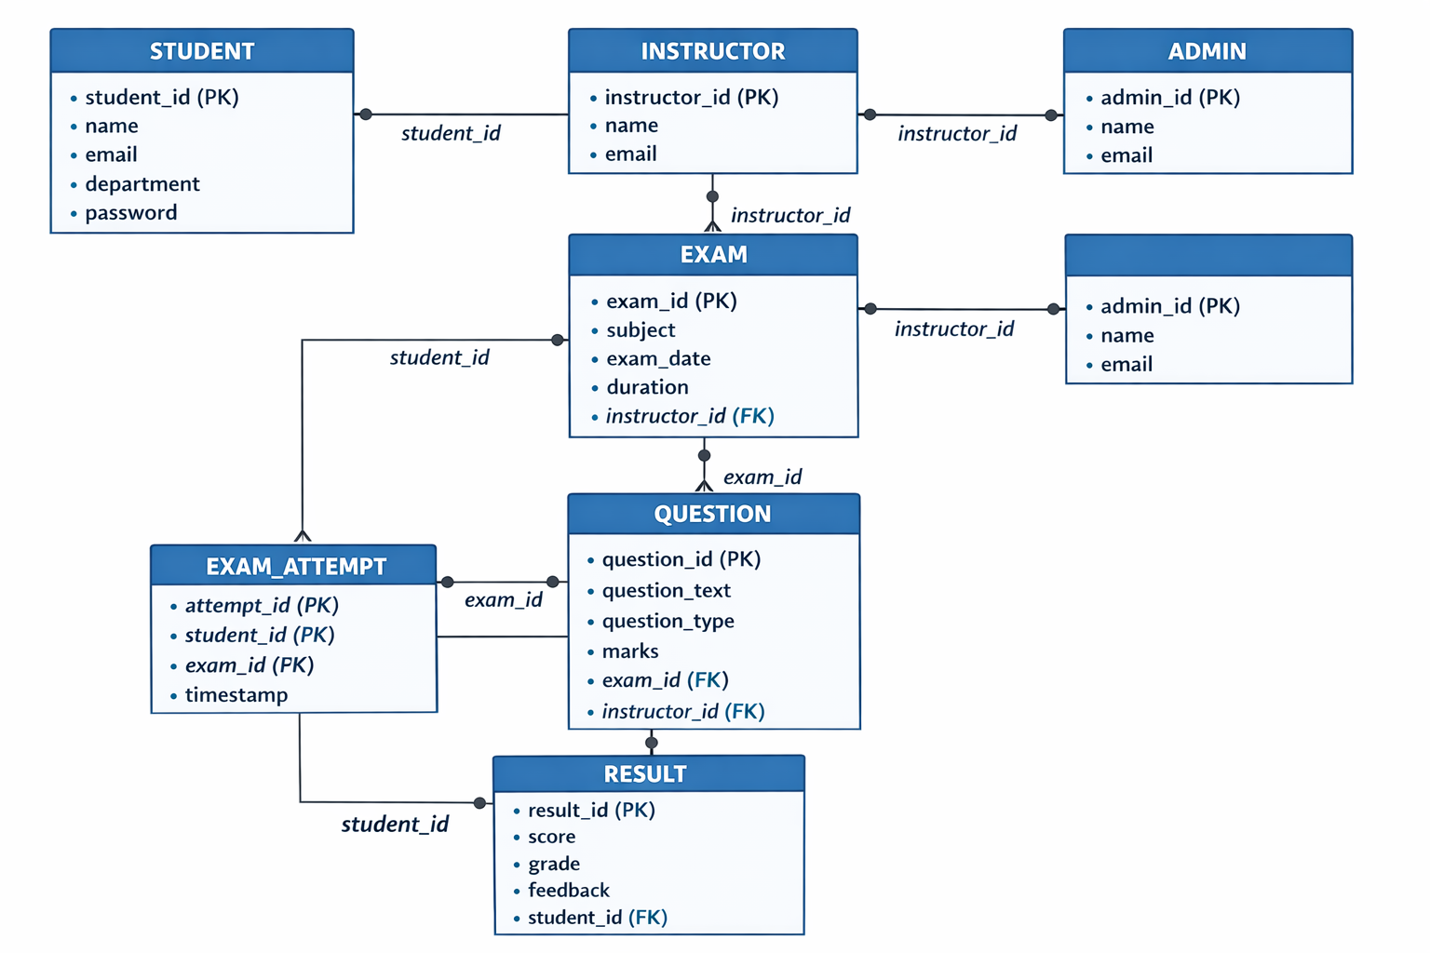

4.2 Normalization

Normalization is a systematic approach to organizing data in a relational database to reduce
redundancy and improve data integrity. It involves decomposing complex tables into simpler,

well-structured ones while preserving relationships. The normalization process typically
follows three key stages: First Normal Form (1NF), Second Normal Form (2NF), and
Third Normal Form (3NF).

4.2.1 Application of Normal Forms

Example:1

student_id | name (Non-Atomic) | email | department | password
101 | password | bereket@mtu.edu | Computer Science, IT | B_12345
102 | B_12345 | bitania@mtu.edu  mesfen@mtu.com | Software Engineering | Bit@2025
103 | Dawit Isaac | dawit@mtu.edu,  issecl@gmail.com | Computer Science | P@ssw0rd1
All attributes contain atomic (indivisible) values.
There are no repeating groups or arrays.
Applying 1NF Construction
To satisfy 1NF, we "flatten" the table. We split the names and create a new row for every
unique combination of email and department.
Constructed 1NF Student Table
student_id (PK) | first_name | Last_name | Email(pk) | Department(pk) | passwerd
101 | Bereket | Desalegn | bereket@mtu.edu | Computer Science | B_12345
101 | Bereket | Desalegn | bereket@mtu.edu | IT | B_12345
102 | Betania | Elais | bitania@mtu.edu | Software Engineering | Bit@2025
102 | Betania | Elais | mesfen@mtu.com | Software Engineering | Bit@2025
103 | Dawit | Isaac | dawit@mtu.edu | Computer Sinece | dw@ssw0rd1
103 | Dawit | Isaac | issecl@gmail.com | Computer Sinece | dw@ssw0rd1
The Rule of 2NF
1. Must be in 1NF: Every cell has a single value (which we already did).
2. No Partial Dependency: Every non-key attribute must depend on the entire Primary
Key, not just a part of it.
1. Identifying the Problem in 1NF
In your 1NF table, we used a Composite Primary Key (student_id + email + department).
However, notice that:
• first_name, last_name, and password depend only on the student_id. They don't change if
the email or department changes.
• This is a Partial Dependency, which causes massive data redundancy.
2. The 2NF Construction (Splitting Tables)
To fix this, we break the 1NF table into three distinct tables. Each table now has a single-
purpose Primary Key.
Table 1: Students (Core Info)
This table stores data that belongs solely to the student.

student_id (PK) | First_name | Last_name | passwerd
101 | Bereket | Desalegn | B_12345
102 | Betania | Elais | Bet@2025
103 | Dawit | Isaac | P@ssw0rd1
Table 2: Student_Emails
Since a student can have multiple emails (like your image showed), we separate them to
avoid repeating the student's name and password for every email

.
Email(pk) | student_id (PK)
bereket@mtu.edu | 101
bitania@mtu.edu | 102
mesfen@mtu.com | 102
Isaac@mtu.com | 103
dawit@mtu.com | 103
Table 3: Student_Departments
This allows a student to be part of multiple departments without creating duplicate student
records.
student_id (FK) | department
101 | Computer sinece
101 | IT
102 | Softwear engenering
103 | Computer sinece
Third Normal Form (3NF)
The Rule of 3NF
1. Must be in 2NF: The tables are already split to remove partial dependencies.
2. No Transitive Dependency: A non-key column must not depend on another non-key
column. All attributes must depend only on the Primary Key.
The 3NF Construction
To fix this, we move the department details into their own independent table. This ensures
that if a Department Head changes, you only update it in one place, not for every student.
Table 1: Students (3NF)
Only keeps a reference to the department.
student_id (PK) | first_name | last_name | dept_id (FK)
101 | Bereket | Desalegn | D01
102 | Bitania | Elais | D02
Table 2: Departments (3NF)
Stores the specific details about the department.

dept_id (PK) | department_name | head_of_department | office_location
D01 | Computer sinece | Dr. Abebe | Building. A
D02 | Softwear engenering | Prof. Martha | Building.B

EXAMPLE .2
instructor_id | name (Non-Atomic) | email (Repeating Group) | department | password
1 | Dr. Abebe Kebede | abebe@mtu.edu, abebe.k@gmail.com | Computer Science, IT | Abebe@2025
2 | Prof. Martha Hailu | martha.h@mtu.edu | Software Engineering | Mar_Secure!
3 | Mr. Samuel Tadesse | samuel@mtu.edu | Mathematics, Statistics | Sam_Pass99
The Rules Applied
1. Atomicity: We split the name into first_name and last_name so each cell holds one piece of data.
2. No Repeating Groups: We removed the lists in email and department. Instead of one row with a list, we create new rows for each unique value.
3. Unique Identifier: Every row is now uniquely identifiable, though we use a
Composite Primary Key (a combination of ID, Email, and Department) because the instructor_id alone now repeats.
Constructed 1NF Instructor Table
instructor_id | first_name | first_name | email | department | password
1 | Abebe | kebede | abebe@mtu.edu | Computre sinece | Abebe@2025
1 | Abebe | Kebede | abebe@mtu.edu | IT | Abebe@2025
2 | Marta | Hailu | martha.h@mtu.edu | Software Engineering | Mar_Secure!
3 | samual | tadese | samuel@mtu.edu | Maths | Sam_Pass99
3 | samual | tadese | samuel@mtu.edu | Statstices | Sam_Pass99
The Rule of 2NF
1. Must be in 1NF: The table must already have atomic values and no repeating groups.
2. No Partial Dependency: Every non-key attribute must depend on the entire Primary
Key. If an attribute depends on only part of a composite primary key, it must be
moved to a different table.
3. 1. Identifying the Problem in 1NF
In the 1NF table we constructed, the Primary Key is a Composite Key: (instructor_id, email,
department).
The Violation:
• first_name, last_name, and password depend only on the instructor_id.
• They do not depend on the email or the department.
• Because these attributes depend on only part of the key, we have a Partial
Dependency. This causes us to repeat the instructor's name and password multiple
times unnecessarily.
2. The 2NF Construction (Splitting the Tables)
To fix this, we break the 1NF table into three separate tables. This ensures that data is stored
only where it is fully dependent on the key.23
Table 1: Instructors (Core Information)
This table stores data that belongs strictly to the instructor's identity
instructor_id (PK) | first_name | last_name | password
1 | Abebe | Kebede | Tadesse
2 | Abebe | Hailu | Mar_Secure!
3 | Samuel | Tadesse | Sam_Pass99
Table 2: Instructor_Emails
Since an instructor can have multiple emails, we link them to the ID here.
email (PK) | instructor_id (FK)
abebe@mtu.edu | 1
abebe.k@gmail.com | 1
martha.h@mtu.edu | 2
samuel@mtu.edu | 3
Table 3: Instructor_Departments
This handles the case where an instructor works in multiple departments.

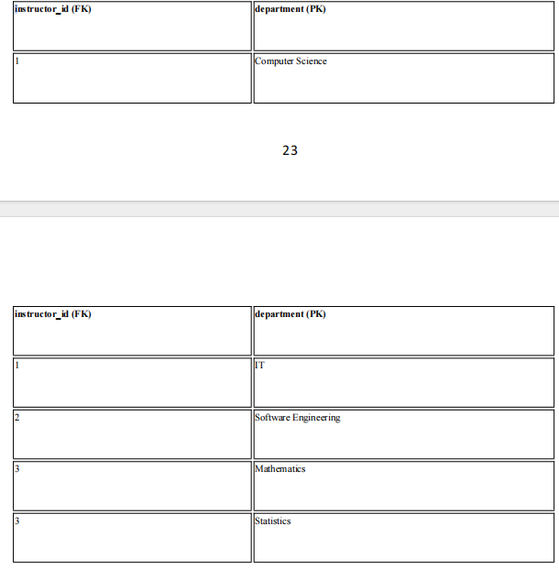

The Rule of 3NF
1. Must be in 2NF: The tables are already split to remove partial dependencies (which
we completed in the previous step).
2. No Transitive Dependency: A non-key column must not depend on another non-key
column. In database terms: "The attribute must depend on the key, the whole key,
and nothing but the key."
1. Identifying the Transitive Dependency
In your current 2NF setup, the Instructor_Departments table has a hidden problem if we want to
store more info about the department:
Non-3NF Table Example:
| instructor_id (FK) | department_name (PK) | hod_name (Head of Dept) | office_location |
| :--- | :--- | :--- | :--- |
| 1 | Computer Science | Dr. Abebe | Building A |
| 3 | Mathematics | Prof. Martha | Building C |
The Problem:
• instructor_id $\rightarrow$ department_name
• department_name $\rightarrow$ hod_name25
• Therefore, instructor_id $\rightarrow$ hod_name is a transitive dependency. The Head
of Department depends on the Department Name, not directly on the Instructor ID. If
the HOD changes, you would have to update it for every instructor in that department,
which causes errors.
2. The 3NF Construction
To satisfy 3NF, we move the department details into their own independent table.
Table 1: Departments (New 3NF Table)
This table stores facts about the department once
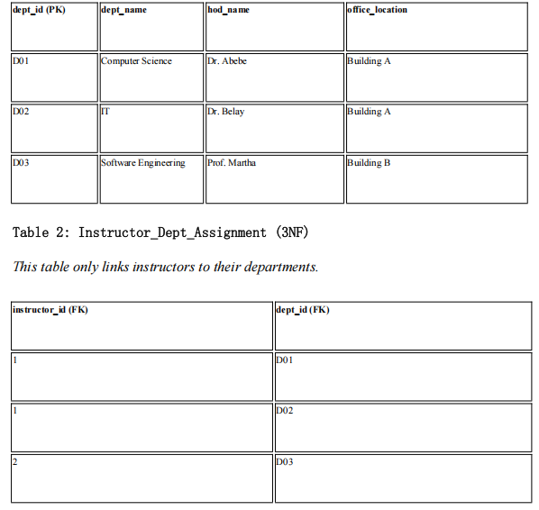

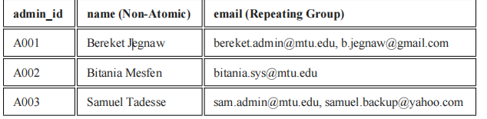

The Rules Applied
1. Atomicity: We split the name into first_name and last_name. Each cell now holds only
one piece of information.
2. No Repeating Groups: We remove the comma-separated lists of emails. Instead,
each email for an admin gets its own separate row.
3. Unique Primary Key: Since the admin_id now repeats, we use a Composite Primary
Key ($admin\_id$ + $email$) to ensure every row is unique.
Constructed 1NF Admin Table
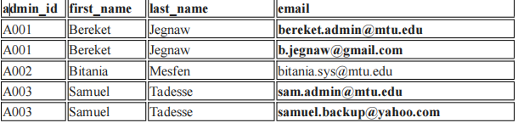

The Rule of 2NF
1. Must be in 1NF: The table must already have atomic values and no repeating groups.
2. No Partial Dependency: Every non-key attribute must depend on the entire Primary
Key. If an attribute depends on only part of a composite primary key, it must be
moved to a different table.
1. Identifying the Problem in 1NF
In the 1NF table for Admin, the Primary Key is a Composite Key: (admin_id, email).
The Violation:
• The attributes first_name and last_name depend only on the admin_id.
• They do not depend on the email. For example, if you change the email, the admin's
name remains the same.
• Because these attributes depend on only part of the key (admin_id), we have a Partial
Dependency. This causes us to repeat the admin's name for every email they own.27
2. The 2NF Construction (Splitting the Tables)
To satisfy 2NF, we split the 1NF table into two separate tables.
Table 1: Admins (Core Information)
This table stores the data that belongs strictly to the admin's identity.

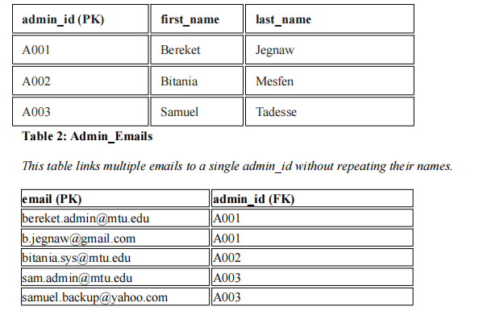The Rule of 3NF
1. Must be in 2NF: The tables are already split to remove partial dependencies (Admins
and Admin_Emails are separate).
2. No Transitive Dependency: A non-key column must not depend on another non-key
column. All attributes must depend only on the Primary Key ($Admin\_ID$).
1. Identifying the Problem (Transitive Dependency)
In a standard Admin table, 2NF often already satisfies 3NF because there are few attributes.
However, in a 2nd-year project, you might be asked to include Admin Roles or Permissions.
Violation Table (Non-3NF):
| admin_id (PK) | first_name | last_name | role_name | access_level |
| :--- | :--- | :--- | :--- | :--- |
| A001 | Bereket | Jegnaw | SuperAdmin | Level 10 (Full) |28
| A002 | Bitania | Mesfen | Moderator | Level 5 (Limited) |
The Problem:
• $admin\_id \rightarrow role\_name$
• $role\_name \rightarrow access\_level$
• Therefore, $admin\_id \rightarrow access\_level$ is a transitive dependency. The
"Access Level" depends on the "Role," not specifically on the person. If you want to
change the Moderator's access level, you would have to find every moderator in the
table and change them individually.
- The 3NF Construction

To fix this, we create a separate table for the roles. This ensures that permissions are managed
in one place.
Table 1: Admin_Roles (3NF)
This stores the definition of each role.

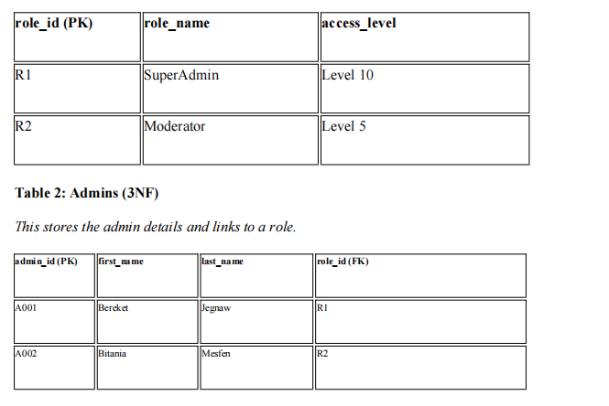
CHAPTER FIVE

Physical Design

The physical design stage involves the transformation of the logical schema into actual
database structures using SQL. It specifies how data will be stored, indexed, and accessed
efficiently in the system. For the Online Examination System, the physical design includes
database creation, table definitions, constraints, and sample data insertion for testing.

5.1 Database Creation

The database is implemented in MySQL. The following tables are created to represent the
entities and relationships defined in the logical design:
✓ Users: Stores information about students, instructors, and administrators.
✓ Courses: Represents academic courses managed by instructors.
✓ Exams: Contains details of scheduled examinations.
✓ Questions: Holds exam questions and multiple-choice options.
✓ Results: Records student performance in exams.
CREATE DATABASE online_exam_db_finals;
USE online_exam_db_finals;
CREATE TABLE Users (
user_id INT PRIMARY KEY IDENTITY(1,1),
full_name VARCHAR(100) NOT NULL,
email VARCHAR(100) UNIQUE NOT NULL,
user_password VARCHAR(255) NOT NULL,
role VARCHAR(20) NOT NULL CHECK (role IN ('student', 'instructor', 'admin') );

CREATE TABLE Courses (
course_id INT PRIMARY KEY IDENTITY(1,1),
course_name VARCHAR(100) NOT NULL,
instructor_id INT,
FOREIGN KEY (instructor_id) REFERENCES Users(user_id) );

CREATE TABLE Enrollment (
user_id INT NOT NULL,
course_id INT NOT NULL,
enrollment_date DATE,
PRIMARY KEY (user_id, course_id),
29FOREIGN KEY (user_id) REFERENCES Users(user_id),
FOREIGN KEY (course_id) REFERENCES Courses(course_id)
);
CREATE TABLE Exams(
exam_id INT PRIMARY KEY IDENTITY(1,1),
course_id INT NOT NULL,
exam_title VARCHAR(100) NOT NULL,
exam_date DATE NOT NULL,
duration_minutes INT NOT NULL,
FOREIGN KEY (course_id) REFERENCES Courses(course_id)
);
CREATE TABLE Questions (
question_id INT PRIMARY KEY IDENTITY(1,1),
exam_id INT NOT NULL,
question_text VARCHAR(MAX) NOT NULL,
question_type VARCHAR(20) NOT NULL CHECK (question_type IN ('MCQ', 'ShortAnswer', 'TrueFalse')),
marks DECIMAL(5,2) NOT NULL,
correct_answer VARCHAR(255),
FOREIGN KEY (exam_id) REFERENCES Exams(exam_id)
);
CREATE TABLE Exam_Attempts (
attempt_id INT PRIMARY KEY IDENTITY(1,1),
exam_id INT NOT NULL,
student_id INT NOT NULL,
timestamp_start DATETIME2 NOT NULL,
timestamp_finish DATETIME2,
CONSTRAINT UQ_ExamStudent UNIQUE (exam_id, student_id),
FOREIGN KEY (exam_id) REFERENCES Exams(exam_id),
FOREIGN KEY (student_id) REFERENCES Users(user_id)
);
CREATE TABLE Attempt_Answerss (
attempt_id INT not null,
question_id INT NOT NULL,
student_response TEXT,
PRIMARY KEY (attempt_id, question_id),
FOREIGN KEY (attempt_id) REFERENCES Exam_Attempts(attempt_id),
FOREIGN KEY (question_id) REFERENCES Questions(question_id)
);
CREATE TABLE Results (
result_id INT PRIMARY KEY IDENTITY(1,1),
attempt_id INT UNIQUE,
score DECIMAL(5,2) NOT NULL,
grade CHAR(2),
feedback TEXT,
FOREIGN KEY (attempt_id) REFERENCES Exam_Attempts(attempt_id) );

5.2 Data Insertion

Sample data is inserted to test the system functionality:
INSERT INTO Users (full_name, email, user_password, role) VALUES
('Prof.melkamu kebedde', 'melkamu@uni.edu', 'profmelkamu23', 'instructor'),
('mr.abnet tesfaye', 'abnet@uni.edu', 'mrabnet23', 'instructor'),
('dr.kebed tasew.', 'kebed@uni.edu', 'drkebed23', 'instructor'),
('Prof.teshal emru', 'teshal@uni.edu', 'profteshal23', 'instructor'),
('Prof.lema abate', 'lema@uni.edu', 'proflema23', 'instructor'),
('bereket jegnaw', 'bereket@student.edu', 'bereket123', 'student'),
('bitania mesfen', 'bitania@student.edu', 'bitania123', 'student'),
('tsega mulatu', 'tsega@student.edu', 'tsega123', 'student'),
('kidus tadese', 'kidus@student.edu', 'kidus123', 'student'),
('harot getahun', 'harot@student.edu', 'harot123', 'student'),
('Dr. Stephen Strange', 'sstrange@uni.edu', 'Stephen43', 'admin'),
('Dr. getachw kebede', 'getachw@uni.edu', 'getachw1254', 'admin'),
('Dr. mamushi fenta', 'fenta@uni.edu', 'fenta34', 'admin'),
('Dr. isreal getachew', 'isreal@uni.edu', 'isreal54', 'admin'),
('Dr. esubalew teshome', 'esubalew@uni.edu', 'esubalew65', 'admin');

INSERT INTO Courses (course_name, instructor_id) VALUES
('fundemntal database', 1),
('fundemntal programing', 2),
('javascrvit', 5),
('liner algebra', 3),
('degital logic disagnin', 4);

INSERT INTO Enrollment values
(6, 1, '2018-02-01'),
(7, 2, '2018-05-05'),
(8, 3, '2018-04-07'),
31(9, 4, '2018-09-06'),
(10, 5, '2018-10-09');

INSERT INTO Exams VALUES
(1, 'database Midterm', '2018-06-03', 45),
(2, 'programing Midterm', '2018-06-03', 45),
(3, 'javascrvit Midterm', '2018-06-03', 45),
(4, 'algebra finalterm', '2018-06-03', 90),
(5, 'dld finalterm', '2018-06-03', 80);

INSERT INTO Questions VALUES
(1, 'What does the abbreviation DDL stand for?', 'ShortAnswer', 15.00, 'Data Definition Language'),
(2, 'Which language is known as a middle-level language?', 'ShortAnswer', 10.00, 'C'),
(3, 'Inside which HTML element do we put the JavaScript?', 'ShortAnswer', 10.00, '<script>'),
(4, 'Is a square matrix invertible if its determinant is zero?', 'TrueFalse', 5.00, 'False'),
(5, 'What is the binary equivalent of decimal 2?', 'ShortAnswer', 10.00, '10');

INSERT INTO Exam_Attempts VALUES
(1, 6, '2018-06-03 08:00:00', '2018-06-03 08:45:00'),
(2, 7, '2018-03-06 09:00:00', '2018-03-06 09:40:00'),
(3, 8, '2018-03-06 10:00:00', '2018-03-06 10:30:00'),
(4, 9, '2018-03-06 11:00:00', '2018-03-06 11:55:00');

INSERT INTO Results VALUES
(1, 0.00, 'F', 'Weak on short answer definitions.'),
(2, 10.00, 'A', 'Perfect answer on programming basics.'),
(3, 0.00, 'F', 'Incorrect tag used for JS insertion.'),
(4, 5.00, 'A', 'Correct understanding of determinants.');

CHAPTER SIX

Results and Discussion

6.1 Outputs (Reports, Forms, Query Results)

To validate the system, several queries and reports were executed. Below are sample outputs:
SELECT * FROM Users;

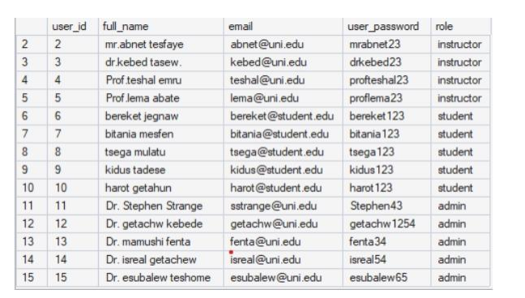

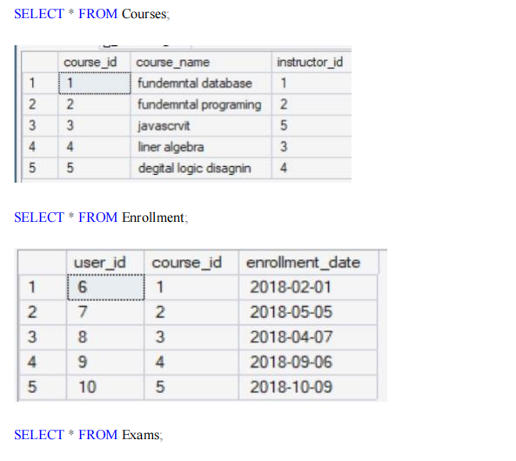

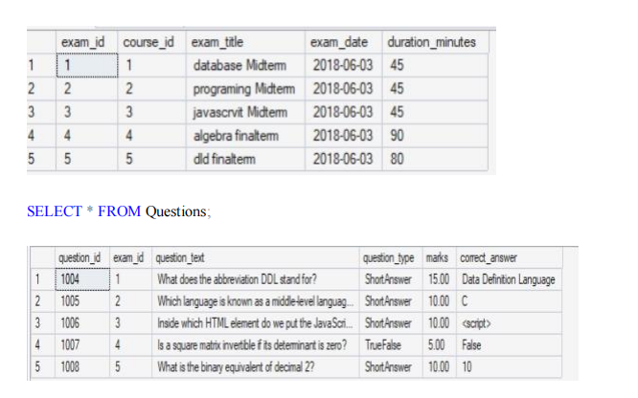
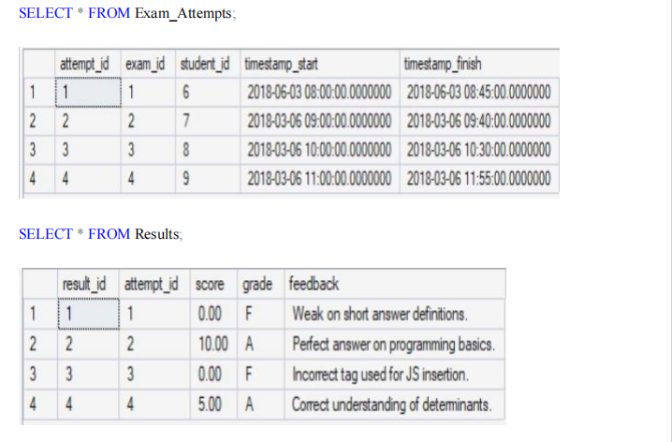
If you want to see a complete report (Student Name + Exam Title + Score) instead of
looking at them one by one, run this "Join" query:
SELECT
U.full_name AS Student_Name,
E.exam_title AS Exam,
R.score AS Final_Score,
R.grade AS Grade,
R.feedback AS Teacher_Comments
FROM Results R
JOIN Exam_Attempts EA ON R.attempt_id = EA.attempt_id
JOIN Users U ON EA.student_id = U.user_id
JOIN Exams E ON EA.exam_id = E.exam_id;
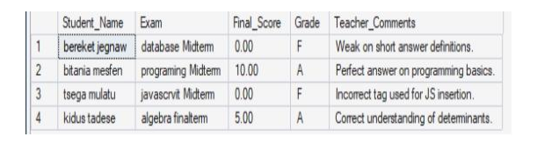
6.2 Discussion: How the System Meets Objectives

The system successfully meets its objectives in the following ways: Efficient exam
management: Instructors can create courses, schedule exams, and add questions seamlessly.
✓ Secure student records: User roles (student, instructor, admin) ensure controlled access
and data integrity.
✓ Automated result generation: Scores are stored and retrieved instantly, reducing manual
grading effort.
✓ Normalized database design: The schema avoids redundancy and maintains consistency
across tables.
✓ Scalability: The design supports multiple courses, exams, and students without structural
changes.

6.3 Limitations

Despite its strengths, the system has certain limitations:
✓ No user interface: Current implementation is SQL-based; a web or mobile front-end
would improve usability.
✓ Limited authentication: Passwords are stored as plain text; encryption and hashing are
needed for real-world deployment.
✓ Basic reporting: Reports are generated via queries only; graphical dashboards or
analytics are not yet integrated.
✓ No real-time exam monitoring: The system does not prevent cheating or track exam
activity.
✓ Single instructor per course: The schema assumes one instructor per course, limiting
collaborative teaching scenarios.
This section demonstrates that your online examination database system is functional,
meets its core objectives, but also highlights areas for improvement in future development.
Conclusion and Future Scope

Summary of Achievements

The online examination database system was successfully designed and implemented. Key
accomplishments include:
✓ Database creation: A normalized relational schema was developed in MySQL, ensuring
data integrity and scalability.
✓ Entity representation: Core entities such as users, courses, exams, questions, and results
were modeled and implemented.
✓ Sample data insertion: Test records were added to validate system functionality and
demonstrate outputs.
✓ Query outputs: Reports such as student performance, exam questions, and course
enrollment confirmed the system’s ability to generate meaningful academic information.
✓ Objective fulfillment: The system achieved its goals of efficient exam management secure record handling, and automated result generation.
Suggested Improvements While the system meets its objectives, future enhancements can strengthen usability, security, and functionality:
✓ User interface development: Integrating a web or mobile front-end for easier interaction.
✓ Enhanced security: Implementing password hashing, encryption, and role-based authentication.
✓ Advanced reporting: Adding dashboards, analytics, and visualizations for better insights.
✓ Real-time monitoring: Introducing features to track exam activity and prevent malpractice.
✓ Flexible course management: Supporting multiple instructors per course and collaborative exam creation.
✓ Scalability upgrades: Optimizing indexing and query performance for larger datasets.

References

1.Elmasri, R., & Navathe, S. B. (2016). Fundamentals of Database Systems (7th ed.).
Pearson.s
2.Connolly, T., & Begg, C. (2015). Database Systems: A Practical Approach to Design,
Implementation, and Management (6th ed.). Pearson.
3.Coronel, C., & Morris, S. (2018). Database Systems: Design, Implementation, &
Management (13th ed.). Cengage Learning.
4.Silberschatz, A., Korth, H. F., & Sudarshan, S. (2020). Database System Concepts (7th ed.).
McGraw-Hill.
5.MySQL Documentation. (2025). MySQL Reference Manual. Oracle. Retrieved from
https://dev.mysql.com/doc/
6.W3Schools. (2025). SQL Tutorial. Retrieved from https://www.w3schools.com/sql/
7.IEEE. (2025). Guidelines for Academic Database Projects. IEEE Digital Library

